
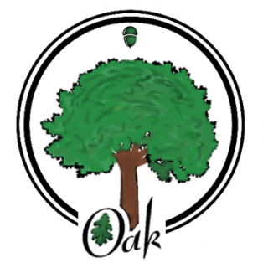
Oak Class
NEWSLETTER

Summer 2026
Welcome Back

The year continues to race along and we will hopefully have some warmer and pleasant weather to enjoy.

This newsletter will hopefully give you more information about the Summer Term and what the children are going to be learning.

If you have any more questions please feel free to get in contact with me through the office or email: oak@newstead.notts.sch.uk

Curriculum

Our topic this term is ‘Who were the Maya and what have we learned from them?’
The children will compare a Non-European civilisation that was around at the same time as the Vikings, who we studied at the start of the year.
History. Our work links History with Geography, specifically where The Maya lived. The second half of the Summer Term then turns to Science, looking at Electricity and Light. We will build on their previous learning of circuits, hopefully designing and building circuits for a purpose.

In Art, we will study some of the tribal artwork produced by civilisations like The Maya. We will reproduce some of them as well as share our thoughts and opinions about the works of art. Our Design & Technology will concentrate on a Mayan pyramid and how they were designed and divided into smaller, internal rooms. So we will be designing and building our own using information from archaeological evidence.
Our English will focus on several books or videos, including: The Delivery, The Piano, Kensuke’s Kingdom, The Highway man. These all link to different areas of our topic work and will give an insight into the Mayans and their beliefs, discoveries and how they have helped us. As we also need to increase the amount of evidence that we have for writing moderation, we will be working on some shorter pieces of work. The Music sessions will begin with listening and appraising some interesting and non-conventional music. We will then be constructing our own pieces of music using GarageBand and real instruments. In Computing we are looking at film-making. Hopefully, we will be able to make the time to create our own informative and curriculum-inspired films and use our music creations in the film as well. In French we will develop our French vocabulary and how to read, write and say sentences relating to telling the time. In R.E. we will look at how religions and beliefs have fought against discrimination and persecution. Finally, in P.E. we will learn skills and techniques for gymnastics and dance and develop teamwork, skills and knowledge.

PE
PE continues to take place every Tuesday and Friday afternoon and will be taught by Miss Martin on Tuesday and myself on Friday. Please ensure that your child has the appropriate kit in school on these days and earrings can be removed for safety reasons.

Reading at home – For the children to be ready for secondary school, reading is so important and regular practise is actively encouraged. The children should be reading at least four times each week. Please encourage your child to read at home, by making it part of their evening routine they could record their progress in their reading diary when they do. I understand that it is not always possible to sit and listen so the children know that they can read on their own, but regular reading is a good habit to get into.
Spellings – The children should continue to work their way through spelling challenge, that can be found in their reading diary and they will be given new spellings.
Maths – They should be practising their times tables each week, even if they know them well and up to our SATs tests, school has invested in some workbooks for them to complete and to encourage them to tackle some of the topics that they need more practise.
Occasionally, children will also have additional pieces of work to complete including topic work, consolidation tasks and SATs revision.

A reminder that SATs week is quickly approaching and will take place week beginning Monday 11th May. Monday to Thursday of that week.

So that the children can perform to their best ability, please encourage them to get plenty of sleep, have some breakfast and are ready for the day.

Thank you for taking the time to read about our Summer term. If you have any questions or concerns please don’t hesitate to get in touch.

Can I also thank you for your continued support throughout the year.

J.Oldfield

