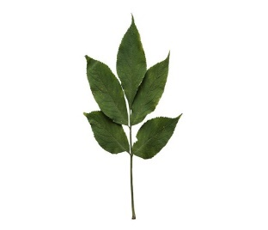
Elm Newsletter – Summer 2026
Welcome back! We hope you had a lovely Easter holiday!
This letter, along with the attached curriculum map, will give you lots of information about what your child will be learning over the coming weeks in Elm class.

Curriculum
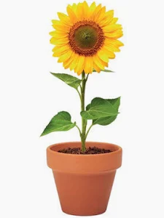
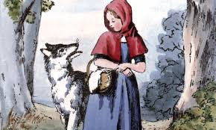
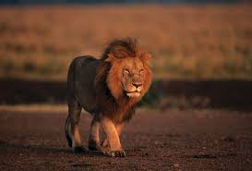
To begin with, our curriculum will have a science focus. We will be learning about animals and how they can be classified. We will then move into Design and Technology, when we will be learning about mechanisms. As part of our Showcase Task, we will make an animal moving picture using sliders and levers. In English, we’ll be thinking about fairy tales, in particular ‘Red Riding Hood’. We’ll be developing our knowledge and skills to write our own fairy tales with a focus on characterization. After half-term, we will be learning all about plants and planting our own seeds. In Art, we’ll be practicing our skills in observational drawing and using a view finder to look at plants, flowers and natural objects in detail.

P.E.
P.E sessions for Elm class will continue to be on a Monday and Thursday each week with Miss. Martin. Please ensure children have their complete kit at school on these days, ensuring long hair is tied back and no jewellery is worn.

Reading books and diaries
Please ensure children have their reading book and diary with them every day for school. The expectation is that they read at least three times a week and for those that do, we always see a huge impact on their confidence and reading ability. Please take the time to listen to your child and record any evidence of this in their reading diary. Year One children will also have flashcards to help them practice their Phonics sounds at home. This just needs to be a simple, repetitive process so these sounds can be embedded for their phonics screening in the summer term.

Important dates this term:
- Week beginning 20th April – London Marathon week
- Friday 1st May – Yorkshire Wildlife Park

Thank you for your continued support,

Mrs. Wensley, Mrs. Greenhalgh and Miss Wade.

