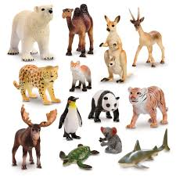
Elm Class – Summer Term 2026
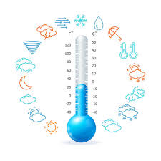
Science
In this term, we will be learning about how animals are classified.
Music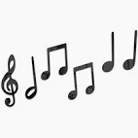
This term in Music, the children will be developing their skills in improvisation and appraisal. They will also be learning about pitch, pulse and rhythm by learning and performing a song called ‘Your Imagination’.
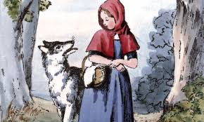

PSHRE/Religious Education
In PSHRE, we will cover units called ‘Keeping Safe’ and ‘Rights and Responsibilities’. Our focus in RE will be on units of work titled ‘Stories by Jesus’ and ‘Symbols’.

How are animals classified?
What are the different parts of a plant called?
What do plants and trees need to grow healthy?

Why do we have to keep our bodies healthy?

Art/Design and Technology/Computing
In Art, our focus will be on observational drawing of plants using a viewfinder. In Design and Technology, our focus is on mechanisms, and we’ll be making our own moving picture. In computing, we will learn about programming using a program called Scratch. 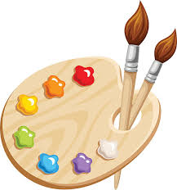

English
We will use the much-loved fairy tale ‘Red Riding Hood’ to be able to write our own fairy tales with a focus on characters. After half-term, our focus will be non-fiction, when we’ll be learning how to write an information text about wolves. Handwriting, spelling and reading continue to be a priority, and we will practice these skills on a daily basis.
P.E.
This term, the children will continue to develop their skills in gymnastics, dance, games, athletics and skipping.
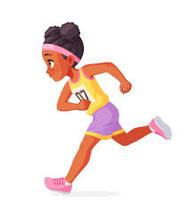
Maths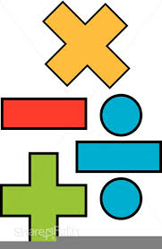
This term, we will begin by building our knowledge and mathematical skills in fractions, multiplication and division, money, time, statistics, position and direction; and place value. We will be continuing to practice counting in 2s, 5s and 10s. Year two children will extend their counting skills to 3s and 4s.

