Elm Class – Spring Term 2026
Music
This term in Music, the children will be developing their skills in improvisation and appraisal. They will also be learning about pitch, pulse and rhythm.
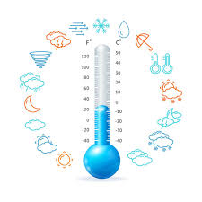
Science
In this term, we will be learning about how the seasons change. We will also conduct an experiment to measure and record temperature over a period of time. Not too cold I hope!
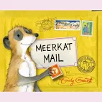
Geography
Our unit of work will all be about hot and cold places in the world. We will learn about the equator and the Northern and Southern hemispheres. After half-term, we will consider how life would be different if we lived in Kenya.

PSHRE/Religious Education
In PSHRE, we will cover units called ‘Keeping Safe’ and ‘Rights and Responsibilities’. Our focus in RE will be on a unit of work titled ‘Celebrations and Festivals’.

How do the seasons change?
Why are some places in the world always hot and others always cold?
What would my life be like if I lived in Kenya?

Why do we have to keep our bodies healthy?

Art/Design and Technology/Computing
In Art, our focus will be on learning the technique, Pointillism. In Design and Technology, our focus is on nutrition and cooking, and we’ll be making our own fruit salads. In computing, we will learn about algorithms, debugging and the International Space Centre. 

English
We will use the much-loved book ‘Meerkat Mail’ to be able to write our own stories set in a hot or cold country. After half-term, our focus will be non-fiction, when we’ll be learning how to write a non-chronological report about an animal. Handwriting, spelling and reading will continue to be a priority, and we will practice these skills on a daily basis.
P.E.
This term, the children will continue to develop their skills in gymnastics, dance, games and skipping.
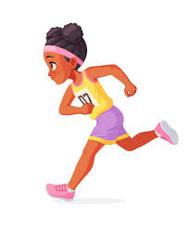
Maths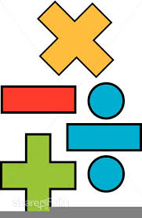
This term, we will begin by building our knowledge and mathematical skills in money, multiplication and division, length and height; and mass, capacity and temperature. We will be continuing to practice counting in 2s, 5s and 10s. Year two children will extend their counting skills to 3s and 4s.

