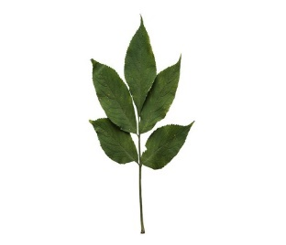
Elm Newsletter – Spring 1 2026
Welcome back! We hope you had a lovely Christmas and Happy New Year!
This letter, along with the attached curriculum map, will give you lots of information about what your child will be learning over the coming weeks in Elm class.

Curriculum

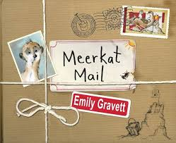
To begin with, our curriculum will have a science focus. We will be learning about seasonal changes and setting up a class experiment to measure and record temperature. We will then move onto geography, when we will be answering the question, ‘Why are some countries always hot and others always cold?’ In English, our book is ‘Meerkat Mail’ by Emily Gravett. We’ll be developing our knowledge and skills to write a story set in a hot or cold place. In art, we’ll be learning about Pointillism, and will be using this technique to paint a picture of a natural landscape.

P.E.
P.E sessions for Elm class will continue to be on a Monday and Wednesday each week with Miss. Martin. Please ensure children have their complete kit at school on these days, ensuring long hair is tied back and no jewellery is worn.

Reading books and diaries
Please ensure children have their reading book and diary with them every day for school. The expectation is that they read at least three times a week and for those that do, we always see a huge impact on their confidence and reading ability. Please take the time to listen to your child and record any evidence of this in their reading diary. Year One children will also have flashcards to help them practice their Phonics sounds at home. This just needs to be a simple, repetitive process so these sounds can be embedded for their phonics screening in the summer term.

Finally, we hope this letter has been useful to you. If you wish you speak to us, please feel free to catch one of us on the gate at the beginning or end of the school day. If, for whatever reason this isn’t possible, we will arrange a suitable time or phone call.

Thank you for your continued support,

Mrs. Wensley, Mrs. Greenhalgh and Miss Wade.

