Elm Class – Autumn Term 2026
Music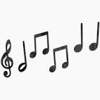
In music, the children will be learning about pulse and rhythm, in a unit of work called ‘Hands, Feet. Heart’. After half term, our music focus will be on learning and performing songs for our Christmas nativity.

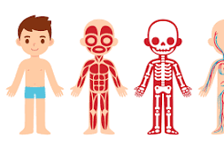Science
We will be learning all about the different parts of the body and, also, what the five senses are. We will be investigating what makes us healthy and designing our very own balanced meal, including all of the different food groups.

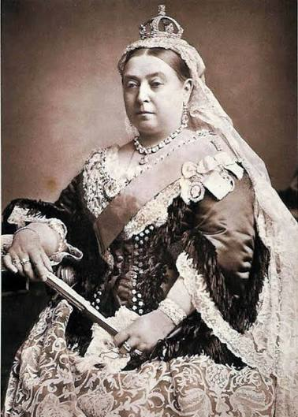
History
We will be learning all about the Victorian era and how this period of time influenced our lives today. As part of this topic, we will be visiting Newstead Abbey to experience a Victorian Christmas.

PSHRE/Religious Education
In PSHRE, we will exploring what individuality means and relationships. In RE, we will be learning about Christian and Jewish leaders.


What are our body parts called and how do we keep them healthy?
What are the five senses?
How did the Victorians influence our lives today?

Art/Design and Technology/Computing
In art, we will be learning how to draw self-portraits. In D & T, we will be learning about wheels and axles, through which we’ll create our own Victorian vehicles. In computing, the focus will be on online safety and improving mouse skills.

Maths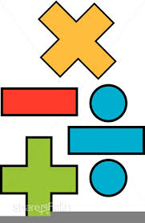
Maths will begin with a clear focus on place value, addition and subtraction, and shape. Year 1 children will develop their counting skills in 2s, 5s and 10s. Year 2 children will build on these and begin to learn the 3s and 4s.

English
Our text will be the much-loved ‘The Lighthouse Keeper’s Lunch’, through which we will write our own stories about a food thief. After half term, we will focus on non-fiction, writing a set of instructions. Handwriting, spelling and reading continue to be a priority, and we will practice these skills on a daily basis.
P.E.
This term, our focus will be on gymnastics and team games.

