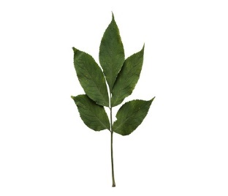
Elm Newsletter – Autumn 2026
Welcome back! We hope you had a lovely summer holiday!
This letter, along with the attached curriculum map, will give you lots of information about what your child will be learning over the coming weeks in Elm class.

Curriculum
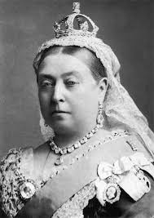
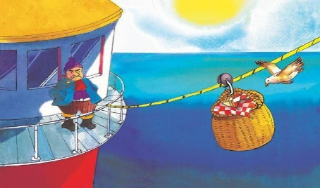
To begin with, our curriculum will have a science focus. We will be learning about the human body, our five senses and what food groups we should eat to have a balanced diet. We will then move onto art and design, where we’ll be learning how to draw a self-portrait, noticing features, proportion and position. As part of our Showcase Task, we will hold an art gallery exhibition. In English, we’ll be using the much-loved story ‘The Lighthouse Keeper’s Lunch’. We’ll be developing our knowledge and skills to write our own stories about a food thief with a focus on description. After half-term, we will be learning all about the Victorians and how they have influenced our lives today.

P.E.
P.E sessions for Elm class will be on a Tuesday and Thursday each week. Please ensure children have their complete kit at school on these days, ensuring long hair is tied back and no jewellery is worn.

Reading books and diaries
Please ensure children have their reading book and diary with them every day for school. The expectation is that they read at least three times a week and for those that do, we always see a huge impact on their confidence and reading ability. Please take the time to listen to your child and record any evidence of this in their reading diary, even if it’s just your initials. Some year One children will also have flashcards to help them practice their phonics sounds at home.

Important dates this term:
- Tuesday 1st September – Admin day for staff
- Wednesday 2nd September – Children back to school
- Friday 16th October – Break up for half-term
- TBA – Newstead Abbey visit

Thank you for your continued support,

Mrs. Wensley, Mrs. Greenhalgh and Miss Wade.

