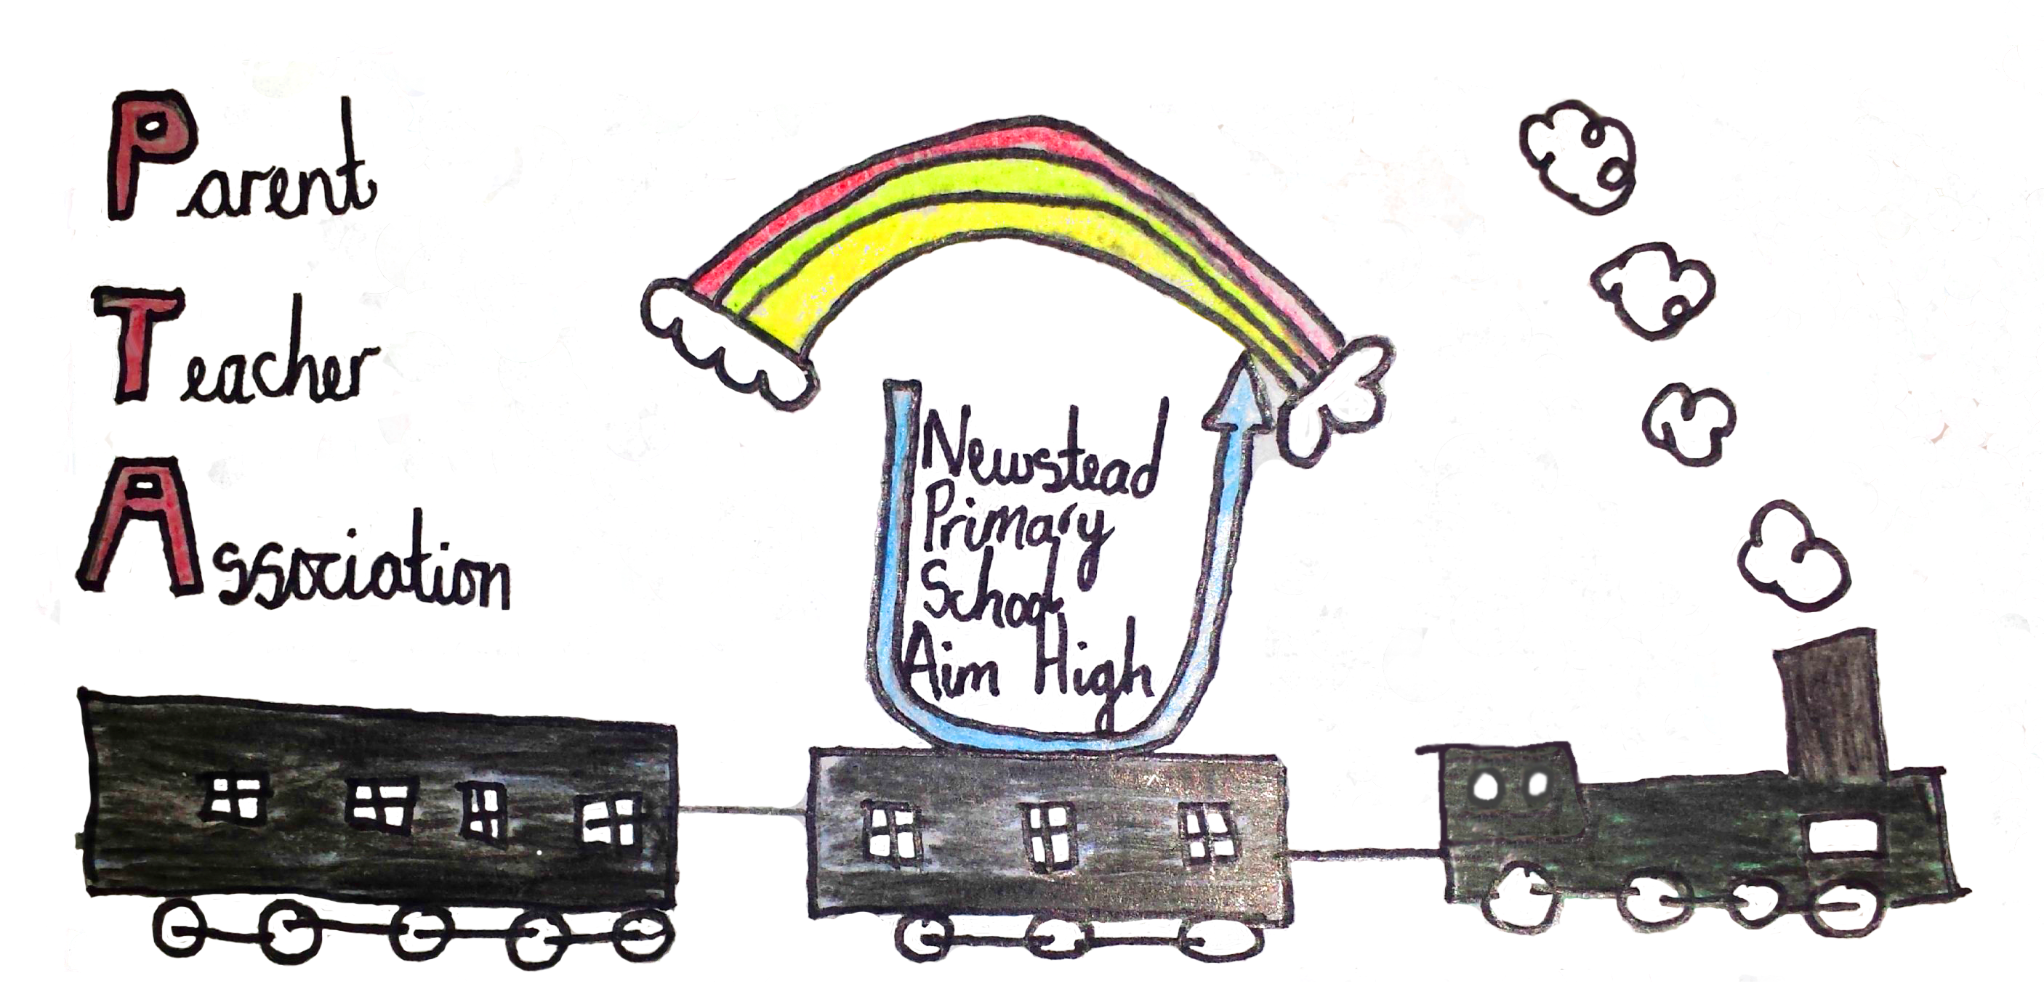
Newstead Primary School PTA
Hucknall Road
Newstead Village
Nottingham
NG15 0BB

Chairperson: Mrs T Bird

Dear Parent/Carer

We’ve got some exciting news to share with you.

Parentkind – a charity that supports school PTAs - have teamed up with Asda, who is making millions of pounds available to donate to primary schools across the UK through their ‘Cashpot for Schools’ initiative. To support our PTA, all you have to do is opt-in through the Asda Rewards app, choose our school, shop and scan in store or shop online at Asda.com.

Between 2nd September and 30th November 2024 – every time you shop with Asda using your Asda Rewards app, Asda will donate 0.5% of the value of your shop to your chosen Primary school. Also, every time somebody opts-in to support our Primary school, Asda will give an additional £1 to the school Cashpot. Plus, it doesn’t stop there – Asda are also giving £50 to every school to get them started.

The supermarket has joined forces with Joe Wicks to support the initiative – look out for the TV advert, radio ads and social media coverage!

It’s as easy as 1,2,3
1. Download the Asda Rewards app, register and opt-in to Cashpot for Schools (make sure you have the latest version of the app installed)
2. Choose our Primary School – either searching by name or postcode
3. Shop instore across Asda and George, or online at Asda.com and start filling your Cashpot as you shop

Asda does the rest, all money raised will be donated to schools to spend on the things they need the most. We are aiming to spend our donations on sports equipment and updating our garden.
Remember, anyone can sign up – so start spreading the news and raising funds for our school.

This initiative is on top of the existing Asda Rewards benefits you get as a shopper – so you won’t lose out on any of your own earnings or Cashpot, so everyone is a winner!

For more details, visit asda.com/cashpotforschools.

Yours sincerely

Mrs T Bird
Chairperson

